# File permissions in Linux

## Project description

The research team at my organization needs to update the file permissions for certain files and directories within the projects directory. The permissions do not currently reflect the level of authorization that should be given. Checking and updating these permissions will help keep their system secure. To complete this task, I performed the following tasks:

## Check file and directory details

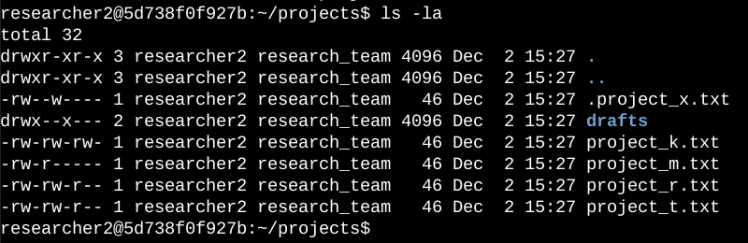

I used the ls -la command to list the file permissions for all the files in the project directory including hidden files. There are 5 text files inside the project directory, one of them being a hidden file, and one other directory.

## Describe the permissions string

In the 10 digit sequence, ‘d’ stands for directory and ‘-’ stands for a file. The first three letters (‘rwx’) represent the permissions for the user. The next three letters determine the permissions for the group and the next three are for other. R stands for read, w stands for write, and x stands for execute. When one of these characters is a hyphen (-) instead, it indicates that this permission is not granted to the user.

## Change file permissions

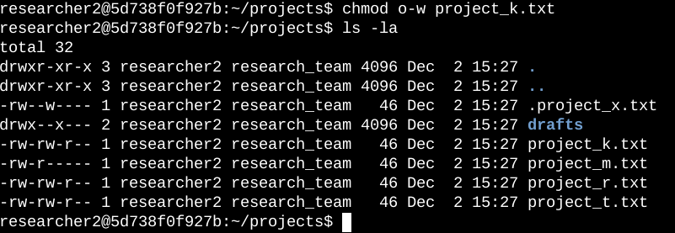

To remove access for writing from the other group I used the above command. Chmod stands for changing permissions, o-w means we are removing the writing permissions for the other group and the 3rd argument, ‘project_k.txt’ is the argument that needs to changes to be applied to. Then the ls -la command is used to verify the correct changes are made.

## Change file permissions on a hidden file

My team wanted the file to not have write permissions for anyone, but the user and group should be able to read the file.

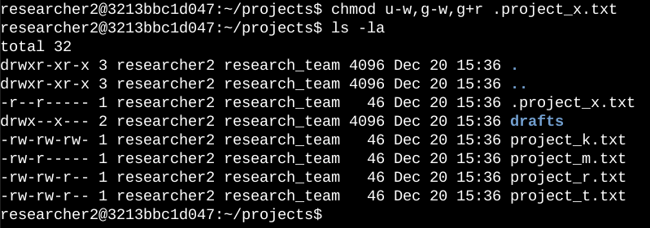

To do this i used the command chmod to change permissions, then i used ‘u-w’ to take the writing permissions for the user. I used ‘g-w’ to take the write permissions off of group, and ‘g+r’ to add reading permissions to the group.

## Change directory permissions

My organization only wants the researcher2 user to have access to the drafts directory and its contents. This means that no one other than researcher2 should have execute permissions.

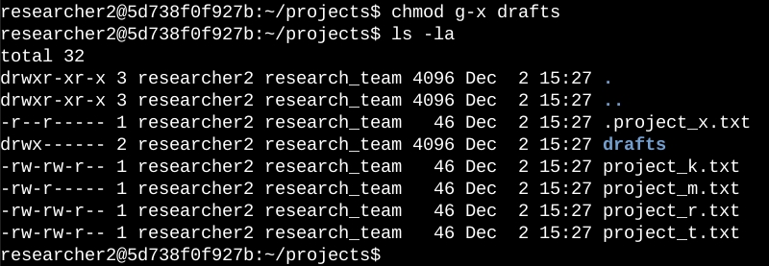

It was previously determined that the group had execute permissions, so I used the chmod command to remove them. The researcher2 user already had execute permissions, so they did not need to be added.

## Summary

I changed multiple permissions to match the level of authorization my organization wanted for files and directories in the projects directory. The first step in this was using ls -la to check the permissions for the directory. This informed my decisions in the following steps. I then used the chmod command multiple times to change the permissions on files and directories.